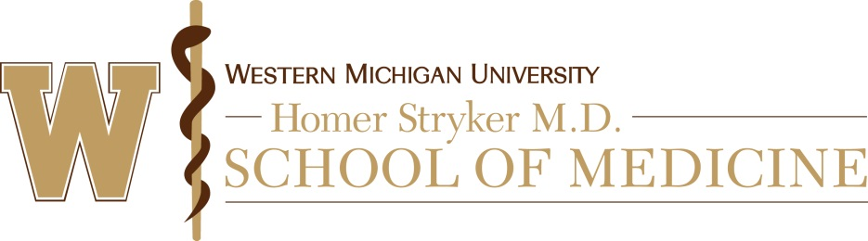

Exemption Determination Checklist

PI Name: |  | WMed IRB #:  (for IRB office use only)
Protocol Title:
Reviewer: | Review Date: Click or tap to enter a date.

- Conflict of Interest
  - As a reviewer, are you an investigator, consultant, collaborator, or study personnel on the proposed study; do you have a financial interest in the study; or do you have any other conflict of interest with this study?
☐ Yes** ☐ No

**If yes, please do not perform the review and contact the IRB Office at 269.337.4345
- Evaluation of Exemption

  - Does the research involve prisoners?
☐ Yes. The research is not eligible for exemption. Go to Section C - Determination
☐ No. Go on to the next question.

Please list any comments:

  - Is the research subject to FDA regulations (e.g. drugs, devices, or biologics).
☐ Yes. Category 6 (noted below) is the only allowable category that is exempt from the requirements of FDA regulations for IRB review. Go on to question #4.
☐ No. Go on to the next question.

Please list any comments:

  - Exemption Categories. In order to be exempt, the only involvement of human subjects must be in one or more of the following categories. Indicate all of the categories which apply:

☐ Category 1: Research conducted in established or commonly accepted educational settings, involving normal educational practices, such as:
☐ research on regular and special education instructional strategies, or
☐ research on the effectiveness of or the comparison among instructional techniques,
curricula, or classroom management methods.

☐ Category 2: Research involving the use of educational tests (cognitive, diagnostic, aptitude, achievement), survey procedures, interview procedures or observation of public behavior.
NOTE 1: If the research involves any of the following, then this exemption does not apply:
☐ a) Information obtained is recorded in such a manner that human subjects can be identified, directly or through identifiers linked to the subjects; AND b) any disclosure of the human subjects' responses outside the research could reasonably place the subjects at risk of criminal or civil liability or be damaging to the subjects' financial standing, employability, or reputation.
☐ The research involves surveys or interviews with children.
☐ Observations of children’s public behavior if the investigator participates in the activities being observed.
NOTE 2: For VA Research: if both of the following are true, this exemption does not apply:
☐ Information obtained is recorded in such a manner that human subjects can be identified, directly or through identifiers linked to the subjects;
☐ Any disclosure of the human subjects' responses outside the research could reasonably place the subjects at risk of loss of insurability.

☐ Category 3: Research involving the use of educational tests (cognitive, diagnostic, aptitude, achievement), survey procedures, interview procedures, or observation of public behavior that is not exempt under Category 2, if:
☐ The human subjects are elected or appointed public officials or candidates for public office; or
☐ Federal statute(s) require(s) without exception that the confidentiality of the personally identifiable information will be maintained throughout the research and thereafter.

☐ Category 4: Research involving the collection or study of EXISTING data, documents, records, pathological specimens, or diagnostic specimens, if:
☐ The sources are publicly available or
☐ The information is recorded by the investigator in such a manner that subjects cannot be identified, directly or through identifiers linked to the subjects

NOTE 1: This category can be applied to research involving the temporary, short-term, recording of identifiers in which an investigator does the following:
- accesses identifiable private information from one source (i.e. outpatient clinic records);
- records only identifiable information (not private information) (i.e . name or medical record number for the purpose of identifying individuals whose existing data, documents, records or specimens) to create a separate dataset of non-identifiable data;
- in a document separate from the document in which identifiable information is recorded, records information obtained from the data, documents, records, or specimens accessed for the intended research purpose to create a separate dataset of non-identifiable data;
- destroys the document containing identifiable information immediately after the data collection is complete; and
- conducts the research analysis on the non-identifiable dataset.

NOTE 2: ALL of the data must exist prior to the start of the research for this exemption to apply.
According to the protocol, will all of the data exist prior to the start of the research?
☐ Yes. This exemption applies
☐ No. This exemption does not apply.

☐ Category 5: Research and demonstration projects which are designed to study, evaluate, or otherwise examine public benefit or service programs, if:
☐ The projects are conducted by or subject to the approval of Federal Department or Agency heads, and,
☐ There is no statutory requirements for IRB review, and
☐ The research does not involve significant physical invasions or intrusions upon the privacy of subjects and,
☐ The exemption is invoked with authorization or concurrence by the funding agency

NOTE: ALL of these criteria must be met for this exemption to apply.
According to the protocol, will all of these criteria be met?
☐ Yes. This exemption applies
☐ No. This exemption does not apply.

☐ Category 6: Taste and food quality evaluation and consumer acceptance studies, if:
☐ Wholesome foods without additives are consumed; or
☐ A food is consumed that contains a food ingredient at or below the level and for a use found to be safe, or agricultural chemical or environmental contaminant at or below the level found to be safe, by the Food and Drug Administration or approved by the Environmental Protection Agency or the Food Safety and Inspection Service of the U.S. Department of Agriculture

NOTE: If this research is FDA regulated, this exemption only applies to the IRB review and it is NOT considered an exemption from the requirement of consent. Unless a waiver of consent is requested, consent will need to be obtained and documented.

  - Is the research eligible for exemption under one or more of the above categories?
☐ Yes. The research is eligible for exemption.
☐ No. The research is not eligible for exemption.

Please list any comments:

- Determination
  - The research meets the following ethical standards for exempt research:
☐ Yes ☐ No - Research holds out no more than minimal risk
☐ Yes ☐ No - Selection of subjects is equitable
☐ Yes ☐ No - Confidentiality provisions are adequate (if collecting identifiable data)
☐ Yes ☐ No – Recruitment process and materials, if applicable, are appropriate ☐ NA
☐ Yes ☐ No - Provisions to protect the privacy interests of participants are adequate
☐ Yes ☐ No - Provisions for consent of subjects are appropriate
☐ Yes ☐ No – Criteria for waiver of HIPAA authorization are satisfied ☐ NA

  - Based on the information in the protocol, I have made the following determination:
☐ Not Human Subjects Research (Complete Human Subject Determination Checklist)
☐ Exempt
☐ Not Exempt. Forwarded for Expedited Review.
☐ Not Exempt. Forwarded for Convened (Full) Review.
☐ Not Exempt. Resubmission Required.

Please list any comments or any additional provisions that are required to protect subjects
(e.g., informed consent)
Signed | Dated

